Place & Earth-Sun Relationships Pre-Test
DO NOT write on this test sheet

This Assessment covers the Five Themes of Geography as well as the Earth’s relationship with the sun, including elements of Climate and Weather.

- The earth’s trip around the sun, 365 ¼ days, is known as . (2.3)
  - Equinox
  - Revolution
  - Deciduous
  - Hypothesis

- The revolution and of the earth cause changing seasons. (2.2)
  - Landmasses
  - Climate
  - Temperature
  - Tilt

- The condition of the atmosphere in one place during a short period of time is known as . (For example a “cold, wet, windy day) (2.4)
  - Rain Shadow
  - Ambient Temperature
  - Weather
  - Air Pressure
  - Climate

- Average weather patterns in a particular area are known as . (2.4)
  - Greenhouse Effect
  - Doldrums
  - Ambient Temperature
  - Temperature
  - Climate

- Match the definitions in the right column to the correct items on the left. (2.1, 2.2, 2.3, 2.4)

Equinox
Axis
Delta
Island
Revolution
Climate
Harbor
Rotation
Plain

              - A land deposit at a river’s mouth
              - Sun is directly over the equator so that day and night are equal in length
              - Weather patterns an area experiences over a long time period
              - Land surrounded by water
              - Spin on the earth’s axis that takes 24 hours
              - A large area of flat or gently rolling land
              - A sheltered area along a seacoast where ships can anchor
              - Trip around the sun that takes 365 ¼ days
              - Imaginary line running through the center of

- This man-made feature is a(n) . (2.1)
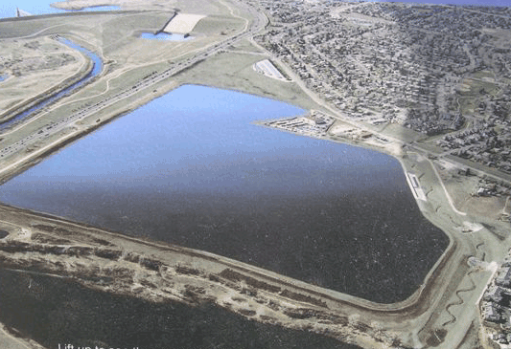
  - Island
  - Plateau
  - Reservoir
  - Mesa
  - Plain
  - Isthmus
  - Peninsula
  - Valley
  - Example of rain shadow

- Match the climate chart (A, B or C) to the description that best fits it. (2.4)
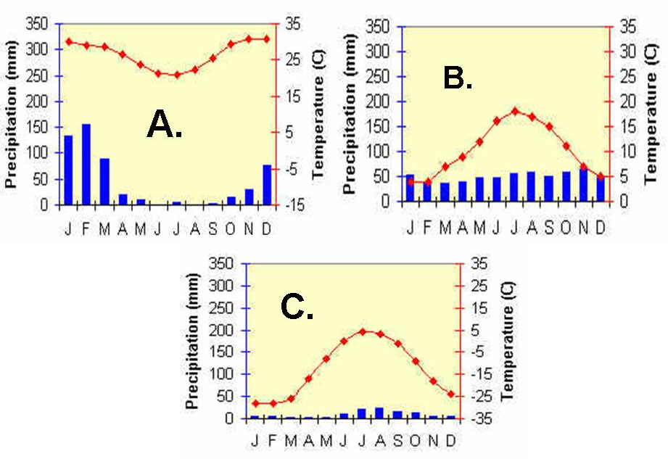

Which place is nearest to the North Pole?
Which place receives the least amount of precipitation?
Which graph is of a place in the southern hemisphere?
Which one is most likely to be found in the United Kingdom?

              - A
              - B
              - C

